**Year 10 General Science Name:_____________________________** /23

**Cycles Quiz**

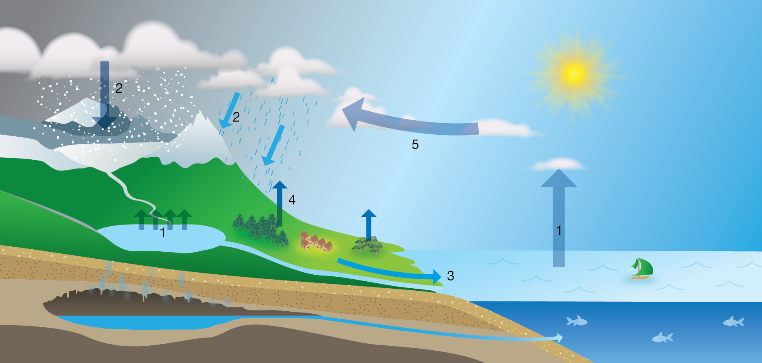

Which cycle is shown in the diagram above? **1**

Describe what is happening at each arrow: **4**

1:

2:

3:

4:

[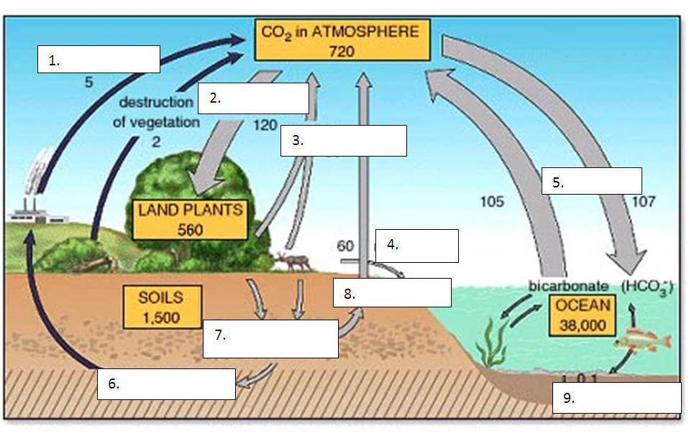](http://www.google.com.au/url?sa=i&rct=j&q=carbon+cycle+worksheet&source=images&cd=&cad=rja&docid=cF5XKQNcVnxzVM&tbnid=hKvaB9EqcSD_pM:&ved=0CAUQjRw&url=http://seivo.com/index.php?page%3Dsearch/images%26search%3Dblank%2Bcarbon%2Bcycle%2Bdiagram%26type%3Dimages&ei=qtF5UviZOIqskgXI-YHwCA&psig=AFQjCNEGQpL2raeFquJA-OtL_N5EU1-ifg&ust=1383801632229790)

**CARBON CYCLE**

**DO NOT FILL IN ALL THE BOXES – read the questions below**

Write the appropriate words in box numbers 2 , 3, 5 and 6. **4**

What are humans doing to increase the amount of carbon following pathway number 1? **1**

What effect is this having on the world? **2**

Another human effect on the carbon cycle is shown in this diagram. What is it? **1**

How does this affect the carbon cycle? **2**

**NITROGEN CYCLE**

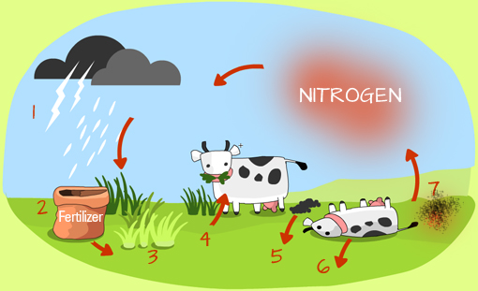

Describe what is happening at each arrow: **3**

3:

4:

5 & 6:

Number 2 shows fertiliser being added to gardens or farms. What can happen to waterways near where the fertiliser is used? Why? **2**

There is an arrow missing from the nitrogen cycle diagram. Draw the arrow on the diagram and explain what it represents (Hint: It involves a symbiotic relationship). **3**